Project Design Phase –II TechnologyStack(Architecture&Stack)

|  |  |
| --- | --- |
| Date | 03 OCTOBER 2022 |
| TeamID | PNT2022TMID49188 |
| ProjectName | Project-**SignswithSmartConnectivityforBetterRoad Safety** |
| MaximumMarks | 4 Marks |

TechnologyArchitecture:

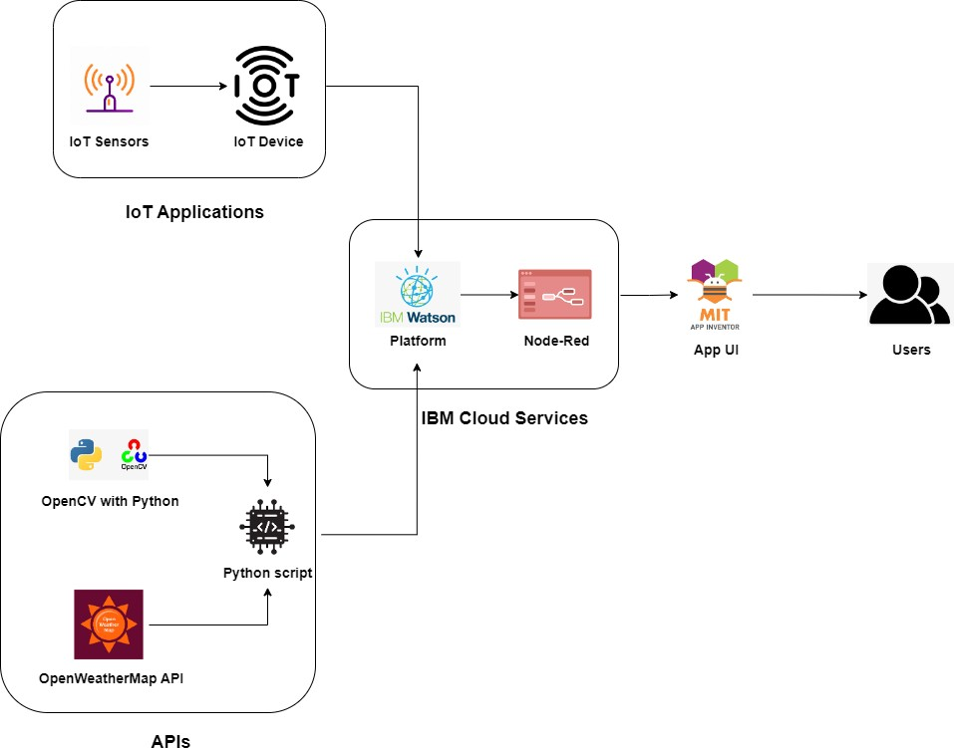

Table-1:Components&Technologies:

|  |  |  |  |
| --- | --- | --- | --- |
| **S.No** | **Component** | **Description** | **Technology** |
| 1. | UserInterface | User caninteractwiththeapp usingMIT App | HTML, CSS, JavaScript / Angular Js /ReactJs |
| 2. | ApplicationLogic-1 | Logic foraprocessinthe application | Java /Python |
| 3. | ApplicationLogic-2 | Logic foraprocessinthe application | IBMWatsonSTTservice |
| 4. | ApplicationLogic-3 | Logic foraprocessinthe application | IBMWatsonAssistant |
| 5. | Database | DataType,Configurationsetc. | IBMCloud |
| 6. | CloudDatabase | DatabaseServiceonCloud | IBMDB2, IBMCloudantetc. |
| 7. | FileStorage | Filestoragerequirements | IBM Block Storage or Other StorageServiceorLocalFilesystem |
| 8. | ExternalAPI-1 | PurposeofExternalAPIusedintheapplication | OpenWeather MapAPI |
| 9. | ExternalAPI-2 | PurposeofExternalAPIusedintheapplication | IBMWatsonPlatform,Node-Red |
| 10. | MachineLearningModel | PurposeofMachine LearningModel | OpenCV |
| 11. | Infrastructure(Server/Cloud) | Application Deployment on Local System / CloudLocalServerConfiguration:  CloudServerConfiguration: | Local, CloudFoundry,Kubernetes |

Table-2:ApplicationCharacteristics:

|  |  |  |  |
| --- | --- | --- | --- |
| **S.No** | **Characteristics** | **Description** | **Technology** |
| 1. | Open-SourceFrameworks | *OpenWeatherMap , NODE-RED, IBM WATSON,MITAppInventor* | IoT,internet |
| 2. | SecurityImplementations | *Powerful security system for everyone'speaceofmind*  *No accessdataHackers cannot accessnetwork* | Firewall,Firebase,cyberresiliency,strategy |
| 3. | ScalableArchitecture | *EASY TO EXTEND THE NETWORK WITH THEAIDOFTHEBANDWIDTHOFTHENETWORK* | IBMCloud |
| 4. | Availability | *Available every time and everywhere 24/7so long as the consumer is signed into thenetwork.* | IBMCloud |
| 5. | Performance | *AIDS MASSIVE RANGE OF USERS TO USETECHNOLOGY* | IBMCloud |